EXPERIMENT 3 - DATA VISUALIZATION

3(a) Data Visualization Using Line Plot
Aim: To show data visualization using a line plot.
import matplotlib.pyplot as cricket Overs = list(range(5, 51, 5))
Indian_Score = [30,55,90,129,165,200,239,270,310,350]
Srilankan_Score = [25,70,90,120,140,170,195,220,255,279]

cricket.plot(Overs, Indian_Score, color="green", label="INDIA") cricket.plot(Overs, Srilankan_Score, color="red", label="SRILANKA") cricket.title("INDIA Vs SRILANKA")
cricket.xlabel("Overs") cricket.ylabel("Score") cricket.legend(loc="center right") cricket.show()
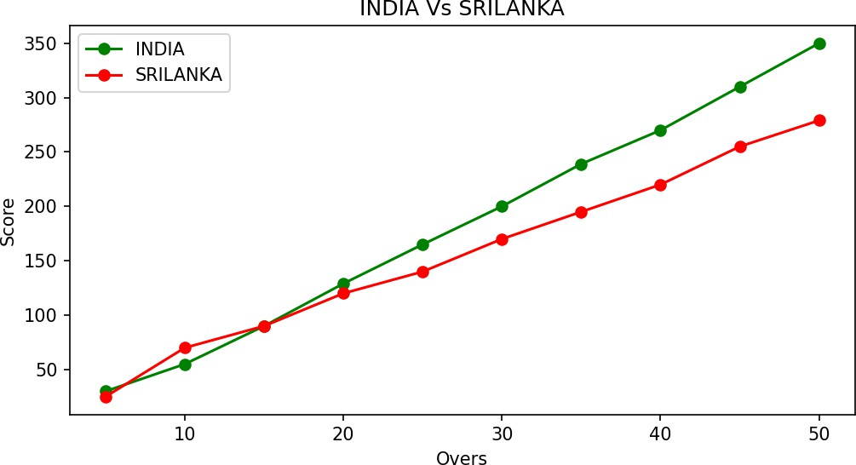

3(b) Data Visualization Using Bar Chart
import matplotlib.pyplot as hscmark import numpy as np

Names = ['SHREE','DEV','KEERTHI','PRIYA','SHAN','KUMARAN']
xaxis = np.arange(len(Names)) Percentage_hsc = [96,91,94,75,45,81]

hscmark.bar(Names, Percentage_hsc) hscmark.xticks(xaxis, Names, rotation=45) hscmark.xlabel("Names of Pupil")

hscmark.ylabel("Percentage")
hscmark.title("Comparison of HSC Percentage", fontsize=20, color="green") hscmark.show()
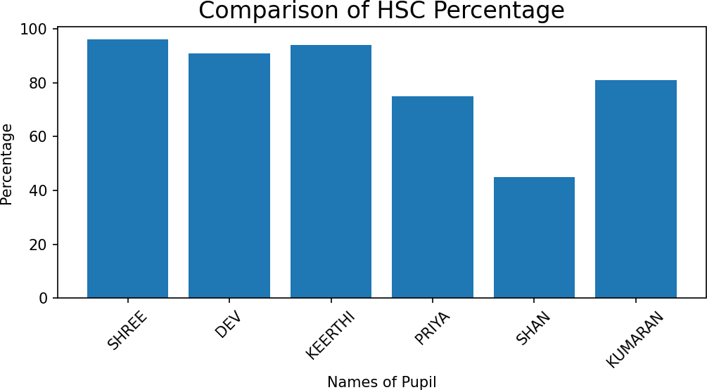

3(c) Data Visualization Using Pie Chart
import matplotlib.pyplot as election

labels = ['CANDIDATE 1','CANDIDATE 2','CANDIDATE 3','CANDIDATE 4'] Votes = [315,130,245,210]
colors = ['green','yellow','red','orange'] explode = (0.2,0,0,0)

election.pie(Votes, labels=labels, colors=colors, explode=explode, autopct='%0.2f%%') election.title('Election Results')
election.show()

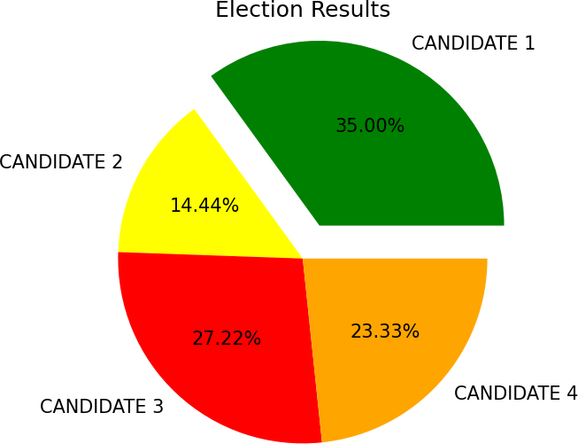

Result
The given data was successfully visualized using line plot, bar chart and pie chart.

